Tutorial Test System

Dynamic Web Open Source Approach

Final CA

Submitted By: Helen O’Brien

T00183586

Computing with Multimedia – Year 2

Date Submitted: 16/12/2015

**Table of Contents**

1. File System 3

2. Overview 3

3. Functional Links 4

4. Functional Elements 5

5. View of Data Tables 6

6. Development 7

# File System

Database: t

SQL File: t.sql

# Overview

Star Software display a Tutorial Test System example on their website, the Test System demonstrates student registration, amending student details and student deregistration, as well as taking a test.

Once the student has completed a tutorial for a module they can then assess their knowledge of the subject by taking a test, the system will randomly generated questions set at one of three levels. The levels are basic, intermediate and advanced. The system then calculates and displays their score.

The student can review their individual test results or review a test profile listing all their test results to assess their overall performance.

The course facilitator is responsible for creating, amending and deleting the questions for the compile test function. They can also review student’s test results, test profiles and module test results. These functions are only seen by the lecturer so the correct answer is displayed as a checking mechanism.

# Functional Links

Functional Links:

Index Page - Main Body

* Create Question
* Amend Question
* Delete Question
* Take Test

Sidebar Links – All pages Except Index Page

* Create Question
* Amend Question
* Delete Question
* Take Test

# Functional Elements

Insert

* Create Question - addQuestion.php
* Amend Question - amendQuestion.php
* Take Test - takeTestQ1.php

- takeTestQ2.php

- takeTestQ3.php

- testResults.php

Delete

* Delete Question - deletedconfQuestion.php

Select

* Amend Question - amendSearchQuestion.php

- amendQuestion.php

* Delete Question - delQuestion.php

- deletedconfQuestion.php

* Take Test - takeTestQ1.php

- takeTestQ2.php

- takeTestQ3.php

Update

* Amend Question - amendUpdatedQuestion.php
* testResults.php

Process

* Take Test - takeTestQ1.php

- takeTestQ2.php

- takeTestQ3.php

- testResults.php

Functional Elements:

Basic level is the only functional level of questions at present.

# View of Data Tables

**Describe Tables**

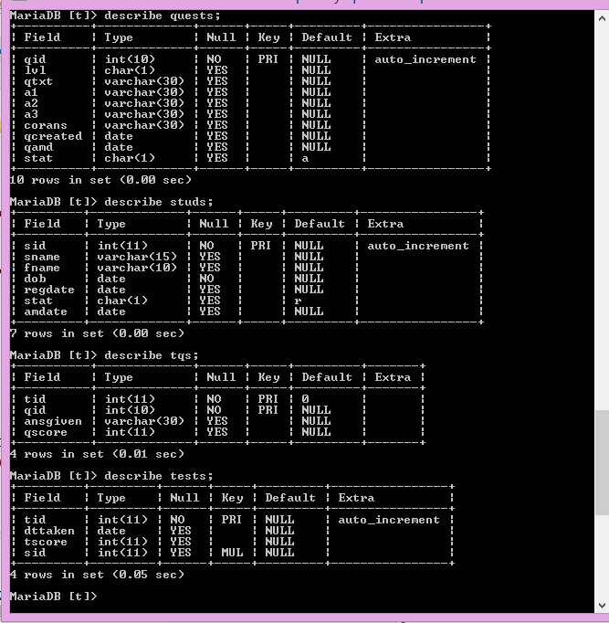

**Data for quests and studs**

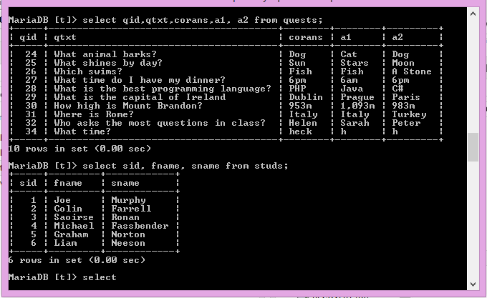

**Data for tests**

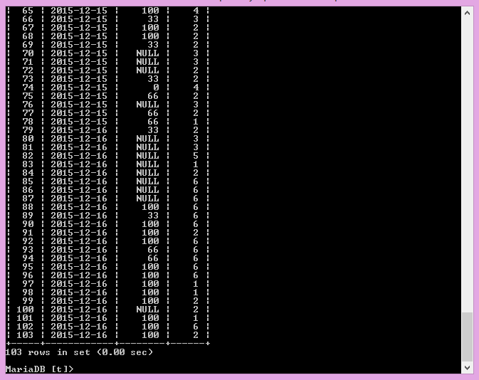

**Data for tqs**

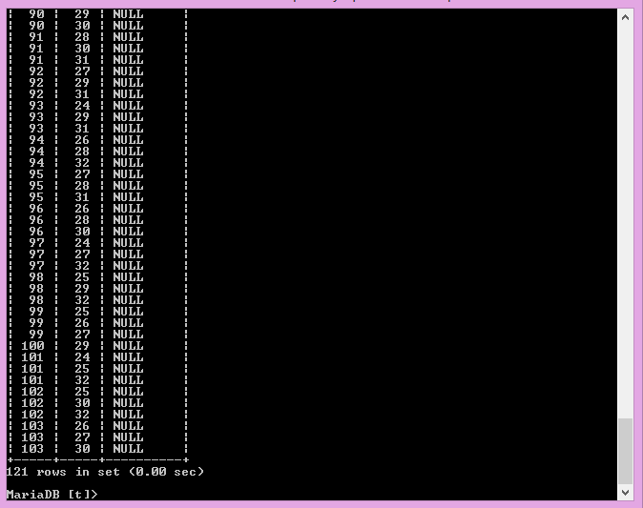

# Development

Basic level questions are the only functional level of questions at the moment, to improve the system the first query would bring back all the questions of the correct level and store them in an array, then count the number of questions in the array and generate a random number within that range. The random number would then be used to get the question from the array and display it.

To improve test performance, a choice of timing the test could be provided.